Figure 1
PC1 and PC2 plotted against each other visualising regional distribution

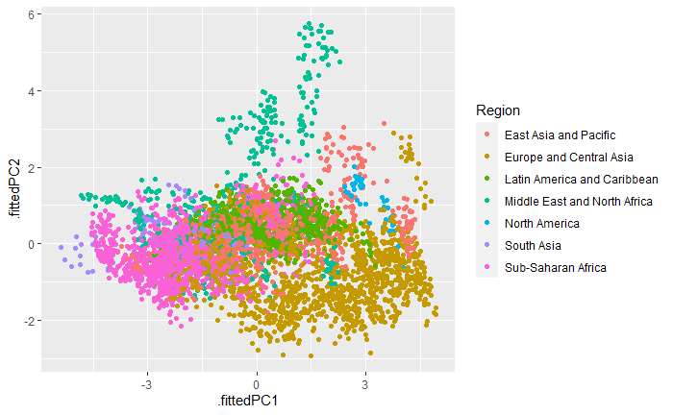
Figure 2
PC3 and PC4 plotted against each other visualising regional distribution

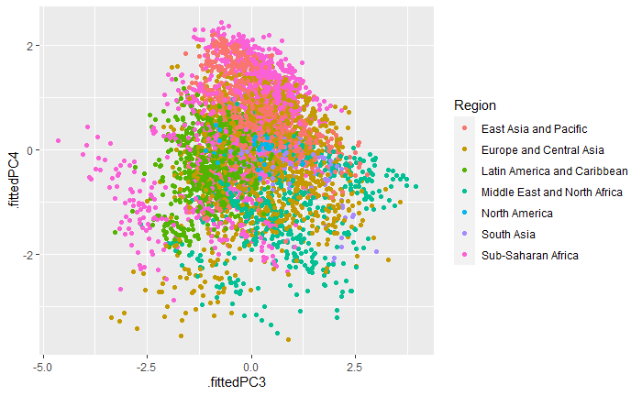

Figure 3
Bar chart visualising which combination of the ten original variables in terms of (directional) weighting is composing the first PC.
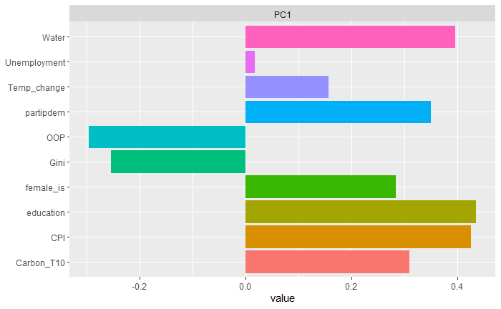
Figure 4
Histograms showing the univariate Distribution of the ten variables composing the ASWell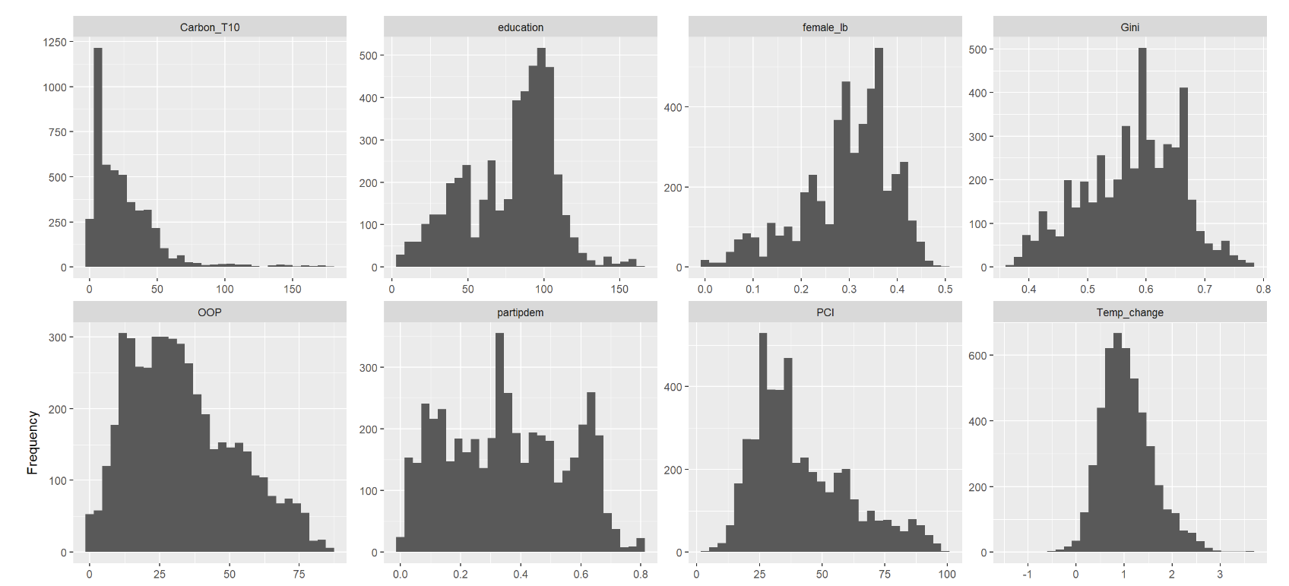
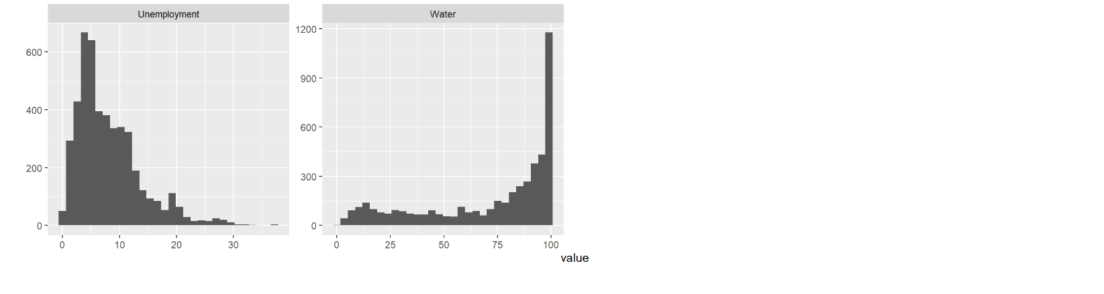
Figure 5
QQ-plots showing the univariate Distribution of the ten variables composing the ASWell
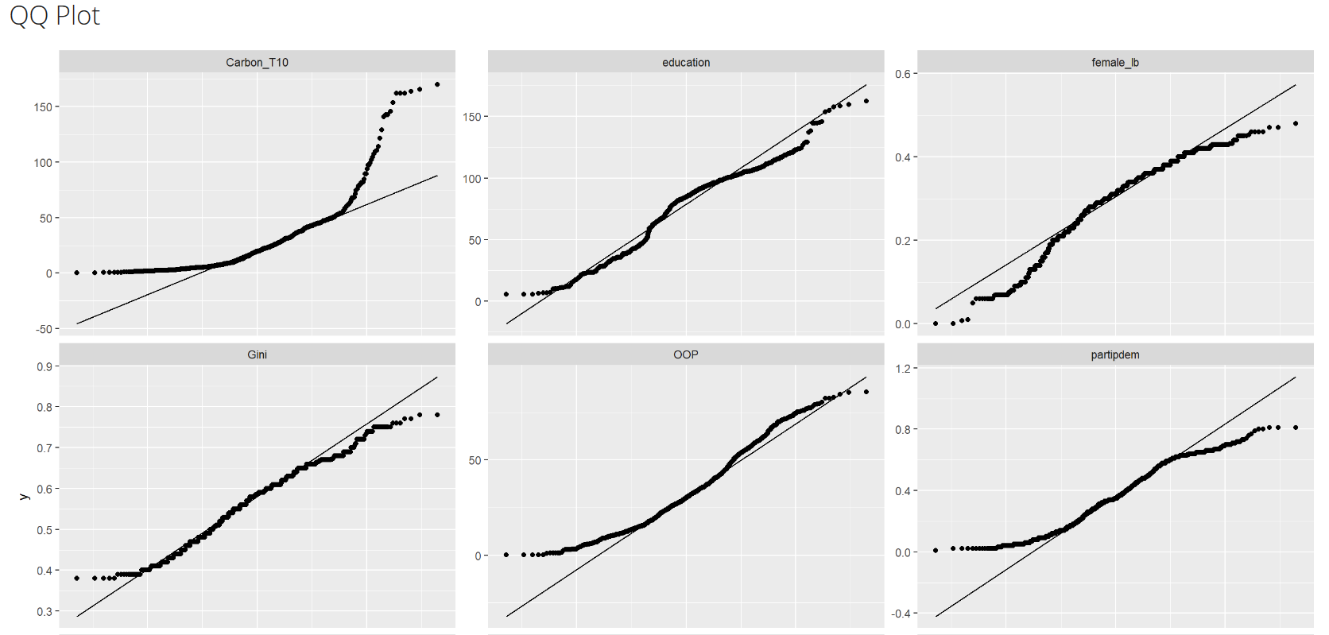
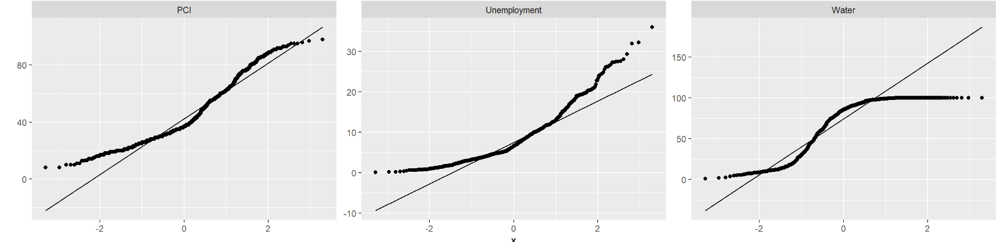

Figure 6
Correlation matrix between the ten variables composing the ASWell
